Animation cards

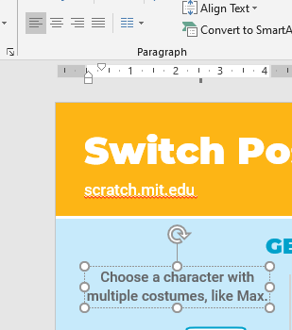

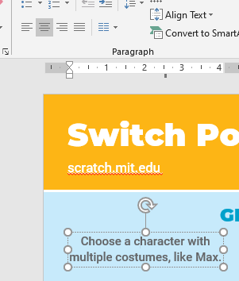Tekst looks centered, but it is using an indentation. Changed into:

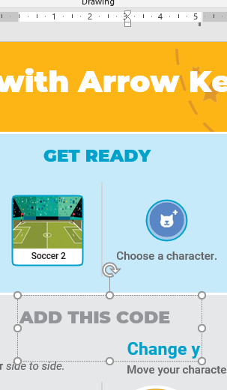Two lines in a single box

Nog doen:

* Footer teksten
* Iconen van choose backdrop / choose a character

